Alderley Edge woodland assessment
Scenario: the National Trust have asked you in as environmental consultants to assess the woodland at Alderley Edge. Using the data you collected on your field work you can write a short summary describing their woodlands.

Tree Density
Calculate an estimate for mean tree density from your own team’s data using the equation given last week (also shown overleaf). Compare your result with table 1 for planted woodlands. What is your result most similar to?
If time, groups could collate the data for the total woodland surveyed. If you calculate the standard deviation for those means, you should see that using the combined larger data produces a more accurate estimate of the mean with a lower deviation.
Table 1. Suggested tree densities for planted woodlands (from Welsh Woodlands and Timber, Coed Cymru). Conifer trees grown for timber are planted close together to make them as straight as possible and to limit the amount of branching lower down the trunk. Broadleaf woodlands are often planted more densely and then are thinned to leave space for large specimen trees like oaks and chestnuts.
Spacing (m between trees) | Example woodlands | Tree density (trees per hectare) | Density
25m | Parkland/savannah | 16 | Low  Very High
5 – 10m | Orchards | 100 - 400 | Low  Very High
3 – 4m | Ornamental/urban | 625 - 1089 | Low  Very High
2.5m | Planted broadleaf | 1600 | Low  Very High
2m | Planted conifer | 2500 | Low  Very High
1m | Soft fruit | 10,000 | Low  Very High

Woodland composition
What is the composition of the woodland (% of each species)?
Sweet chestnut blight is caused by a fungus which attacks bark and can kill sweet chestnut trees. If this disease reaches Alderley Edge, using the calculated tree density and species composition, how many trees per hectare are at risk from this disease?
In heavily infected areas, the fungus will also spread to oak trees. They are not likely to die, but can act as a reservoir for the disease. If the woodland at Alderley Edge was heavily infected, what is the total number of trees per hectare could be carrying the disease?
Did you see evidence for any other tree disease while surveying that you would recommend for further work?
https://www.forestresearch.gov.uk/tools-and-resources/pest-and-disease-resources/sweet-chestnut-blight-cryphonectria-parasitica/
Tree Diameters
Calculate the average diameter for oak, pine, birch and beech. Also calculate the standard deviation which gives a measure of the variation around the mean. Is there and evidence for any of the species having less variation in trunk size? What might this suggest about the age of those trees?

Tree density estimate calculation:
How to calculate the density estimate for each station:

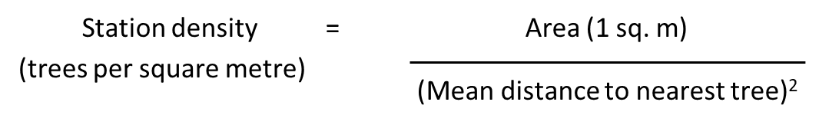

Worked example for station 1
Distance 1= 1.20 m
Distance 2 = 0.45 m
Distance 3 = 0.85 m
Distance 4 = 2.10 m
Mean distance to a plant (d) = 1.15 m
Tree density at station 1 = 1/1.15² = 0.7561 trees per m²

Tree density is often given in trees per hectare, and
1 hectare = 100 m x 100 m = 10,000 m²
So density at station 1 = 7,561 trees per hectare

Once you have a number for the tree density in trees per hectare for each station, estimate the tree density for the whole site by calculating the overall mean. You can also calculate a standard deviation for this mean.

Standard deviation calculation:
√ ∑(density value-mean density value)² / (number of replicate stations–1)

